PROJECT DOCUMENTATION
AI WeatherWise - Deliver intelligent weather
forecasts and insights.
Team ID: SWTID-2026-5815
Team Size: 5
Team Leader : PUSHPA D
Email : pushpa22102006@gmail.com
Team member : POORVI
Email : bpoorvi18@gmail.com
Team member : RAMILA P
Email : ramilachoudhary136@gmail.com
Team member : SANTHIYA M
Email : 25sandhiya3@gmail.com
Team member : SNEHA S
Email : sprav4768@gmail.com

Introduction
AI WeatherWise is a RESTful weather backend built using Node.js, Express.js, MongoDB, and Mongoose.
It provides real-time weather information and uses Google Gemini AI to generate smart weather summaries and personalized recommendations.
The platform also includes JWT authentication, password encryption, favourite location management, fallback support, and centralized error handling for secure and reliable performance.

Project Description
AI WeatherWise is a powerful RESTful backend platform developed using Node.js and Express.js, with MongoDB and Mongoose ODM for efficient data storage and management. It provides real-time weather information integrated with Google Gemini AI to generate intelligent weather summaries and personalized recommendations based on current environmental conditions.
The platform implements secure JWT-based authentication and bcrypt password hashing to protect user accounts and data. It also provides a comprehensive set of endpoints for managing favorite locations and retrieving weather-related insights. A reliable fallback mechanism is included to maintain API functionality even when external API keys are unavailable. In addition, centralized error handling and request sanitization help improve the platform’s security, reliability, and overall performance.
Scenario-Based Case Study
Background
Alex is a travel enthusiast who often visits different cities and needs an efficient way to monitor local weather conditions and get AI-powered activity suggestions based on the current forecast.
Problem
• Difficulty in efficiently tracking and managing multiple favorite weather locations.
• Lack of personalized suggestions for suitable outdoor activities and clothing.
• Need for easy-to-understand, natural language weather summaries instead of only raw weather data.
• Lack of a secure system for storing and synchronizing user preferences across different devices.
Solution
AI WeatherWise offers a centralized service for retrieving weather data and managing AI-based operations. It maintains a secure database for Users and Locations, enabling personalized insights and automated recommendation processes through Google Gemini.
Usage
• User Usage: Manages favorite cities through CRUD operations, retrieves real-time weather data, and requests AI-generated insights, recommendations, and summaries.
• Developer/Admin Usage: Monitors API health, manages overall user registrations, and verifies the integration of weather and AI services.
• Weather Application User: Uses the public weather endpoints to access current weather metrics without needing to create an account.

Outcome
By leveraging AI and centralized data management, users spend less time deciphering raw metrics. The system ensures data integrity via Mongoose schemas and provides high-value, context-aware weather advice through Gemini integrations.
1. Software Requirements
- Operating System: Windows 10/11, macOS, or Linux (supports cross-platform operations).
- Node.js (v16 or above): Runtime ecosystem running server logic and routing infrastructure.
- npm (v8 or above): Node package manager to control operational dependencies.
- Gemini AI SDK: Integration using @google/generative-ai for natural language insights.
- MongoDB: Document NoSQL engine storing users, posts, categories, comments, and analytics metrics.
- Postman: API verification toolkit to assert schema validation responses across administrative route shields.
- Code Editor: Visual Studio Code or similar IDE environment.
2. Hardware Requirements
- Processor: Intel Core i5 (8th Gen or above) / AMD Ryzen 5 or equivalent.
- RAM: 8 GB minimum (16 GB recommended for concurrent instances of MongoDB, processing layers, and execution nodes).
- Storage: 1 GB of available disk workspace.
Epic 1: PROJECT ARCHITECTURE
The AI WeatherWise application follows the MVC architecture to separate business logic from data management. The Controller layer handles weather data retrieval from OpenWeatherMap and generates AI-based insights through Gemini, while the Model layer manages the User and Location entities.

Components Definition

- Interface: API tools like Postman query distinct route paths to extract JSON entities.
- Express Server Gateway: Monitors network ports, maps explicit HTTP methods (GET, POST, PUT, DELETE), parses JSON payloads, and handles CORS headers.
- Authentication & Role Matrix Middleware: Extracts tokens from headers, validates user context signatures, and evaluates if the specific role satisfies authorization thresholds for guarded resource paths.
- Granular Services (Logic Modules): Enforces isolated domain rules for blog lifecycles (Draft, Pending Approval, Scheduled, Published), comment queues, and system reporting indicators.
- Database Interface Layer: Mongoose translates operational application logic into performant native MongoDB queries.
- AI Service Integration: Leverages @google/generative-ai to generate weather summaries and personalized recommendations based on live temperature and conditions.
Entity-Relationship (ER) Diagram Description
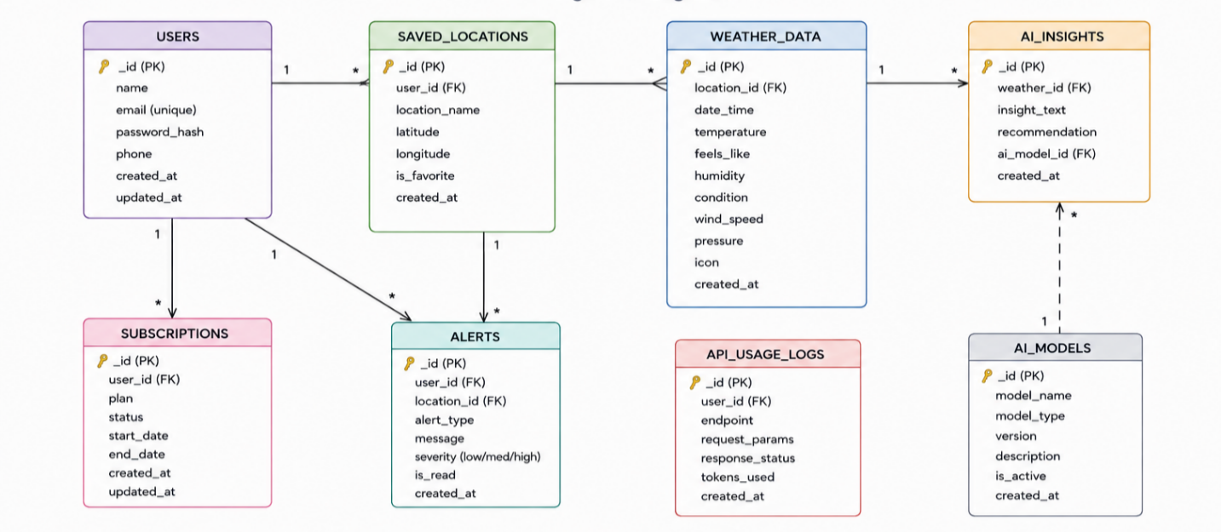The data architecture manages User profiles and their associated favorite Locations through logical references:
1. User Entity
- _id (Primary Key - ObjectId)
- name (String, Required)
- email (String, Required, Unique)
- password (String, Hashed, Required)
- role (String, Default: "reader")
2. Location Entity
- _id (Primary Key - ObjectId)
- user (Foreign Key referencing User Collection)
- city (String, Required)
- country (String, Required)
- createdAt (Date, Default: Now)

Key Structural Mappings
- User to Location (One-to-Many): A registered user can save multiple favorite locations.
Key Features
- Role-Based Route Guarding: Strict token processing blocks unauthorized tiers from modifying core settings.
- CRUD Blog Execution Engine: Complete schema management over content definitions, status states, and asset assignment paths.
- Categorization System: Native tag indices facilitate filtering and querying for enhanced discoverability.
- Comment Moderation Logic: Protected entry points for updating moderation flags (approved, pending, spam).
- Sanitization Safeguards: Payload parameter sanitation prevents XSS vectors and NoSQL parameter manipulation injections.
Roles and Responsibilities
- Admin:
  - Responsible for user account management, including creating, deleting, or suspending accounts.
  - Oversight of API health and system logs to monitor performance.
  - Monitoring and managing database integrity.
- Registered User:
  - Responsible for creating and maintaining a list of favorite locations.
  - Initiating requests for real-time weather data.
  - Interacting with the Gemini AI service for personalized weather summaries and activity recommendations.
  - Managing their own authentication credentials, such as updating profile details.

User Flow:
1. User logs in or registers.
2. User saves a favorite city via the API.
3. User fetches current weather metrics for that city.
4. User requests AI-driven insights (summaries/recommendations) based on the weather data.
5. System validates JWT and returns the requested information.
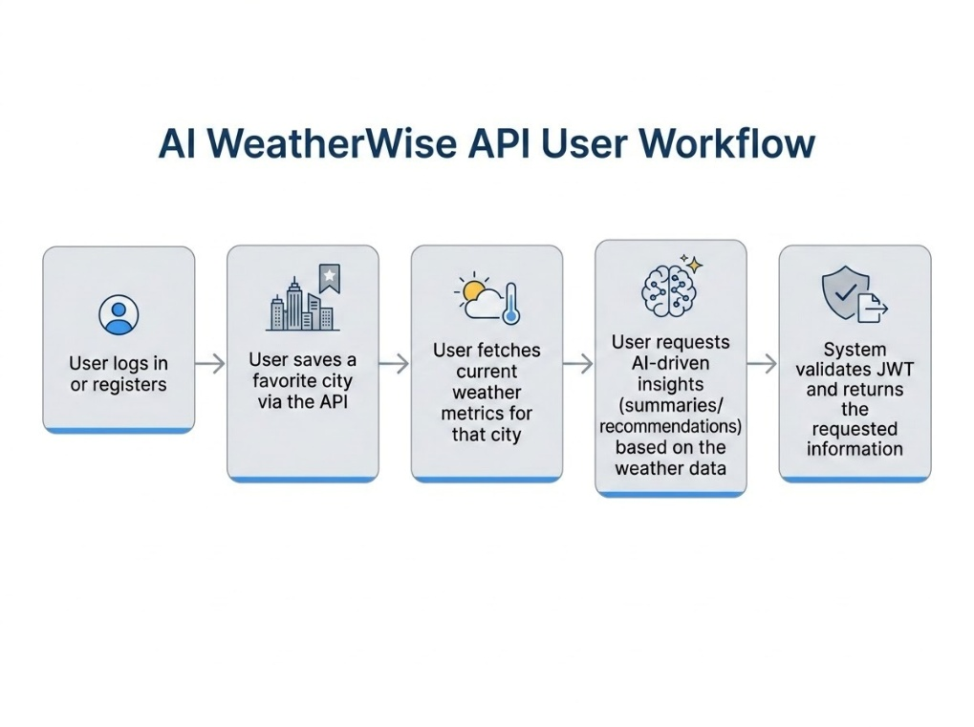
MVC Architecture Pattern
The system architecture structures its source configuration layers around the Model-View-Controller design pattern to completely decouple components:
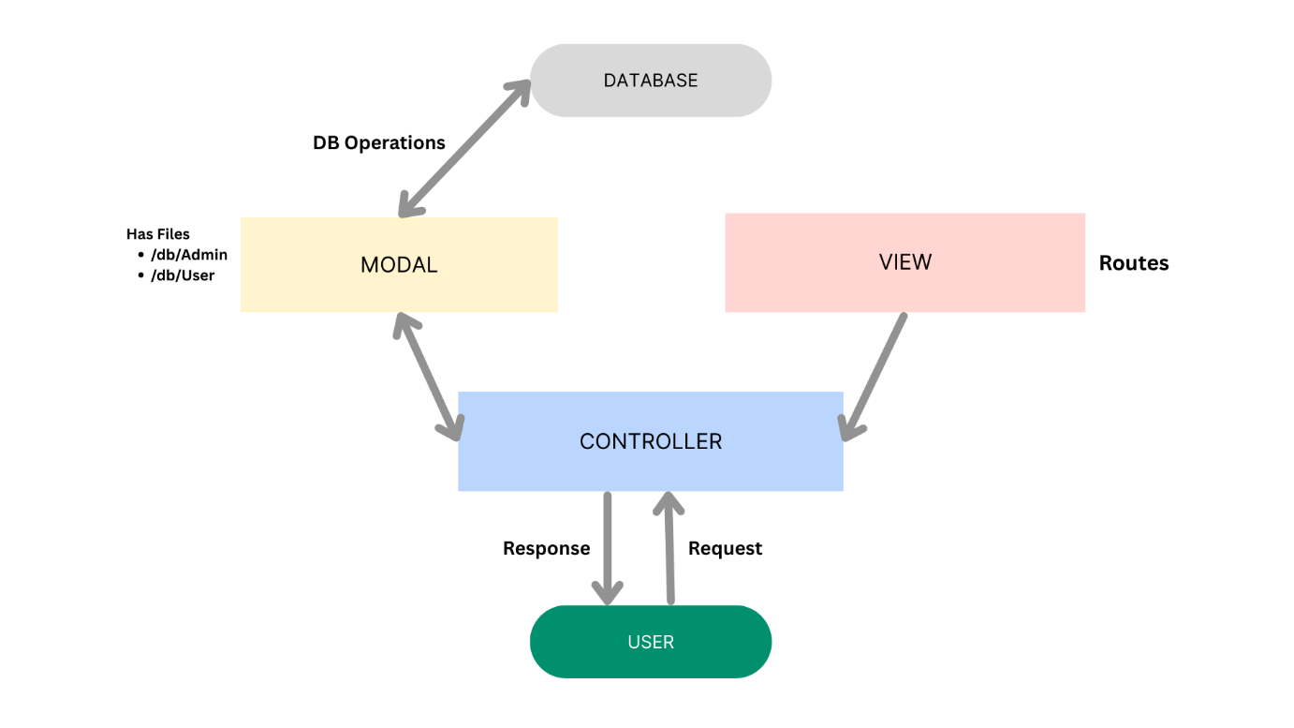
Model Layer (Data Blueprint)
Defines structure blueprints via strongly enforced Mongoose schemas mapping explicit fields into raw collection items inside MongoDB. It sets default states, indexing rules, and transformation parameters before validation persistence occurs.
Controller Layer (Execution Matrix)
The intermediary brain of the ecosystem. It captures request vectors from the execution routes, checks structural request constraints, delegates processing workflows directly to models, and packages the resultant output into standard JSON return arrays.
View Layer (Routing Network Interface)
In this pure headless backend service context, standard user-interface template views do not exist. Instead, the interface layer lives as an API Routing Layer. It links network requests on specified paths directly to their associated controller handler logic maps.

Epic 2: Project Setup and Configuration

Creating the Project Folder
- Create a new folder named AI Weatherwise
- Open the project folder in Visual Studio Code.
- Initialize the project using Node.js and install the required dependencies.

Project Initialization
Open the project folder in the VS Code terminal and execute:
npm init -y
Install the required dependencies:
npm install express mongoose bcryptjs jsonwebtoken cors dotenv multer @google/genai
Install Nodemon for development:
npm install --save-dev nodemon

Create the Following Files
- index.js
- .env
- package.json
- .gitignore

Create the Following Folder Structure
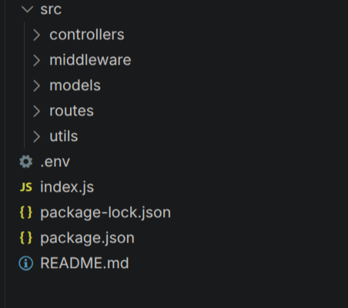

Environment Configuration

Create a .env file in the project root and configure the required environment variables.
PORT=5000
MONGO_URI=your_mongodb_connection_string
JWT_SECRET=your_jwt_secret
GEMINI_API_KEY=your_gemini_api_key

Epic 3: Backend Development

The AI WeatherWise backend is developed using Node.js, Express.js, and MongoDB, following a modular architecture. The application separates routing, controllers, middleware, models, and utility modules to enhance code maintainability and scalability. The backend provides secure REST APIs for authentication, weather data management, AI-powered content generation, and administrative operations.

Backend Structure:
Core System Script Implementations
1. Application Entry Point (index.js)
The index.js file serves as the main entry point of the application. It initializes the Express server, loads environment variables, configures middleware, establishes the MongoDB connection, registers API routes, and starts the server after a successful database connection.
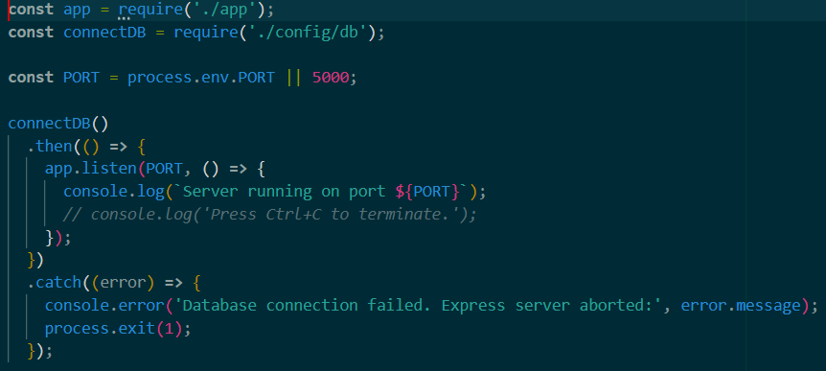

Epic4: Database Configuration
API Testing Demo :

1. Configure MongoDB:

Install Mongoose.
In your Node.js project directory, run:
npm install mongoose
- Create database connection.
- Create Schemas & Models.

Create Database connection:

Now, make sure the database is connected before performing any of the actions through the backend. The connection code looks similar to the one provided below

Mongoose Schema Definitions

Location Schema:
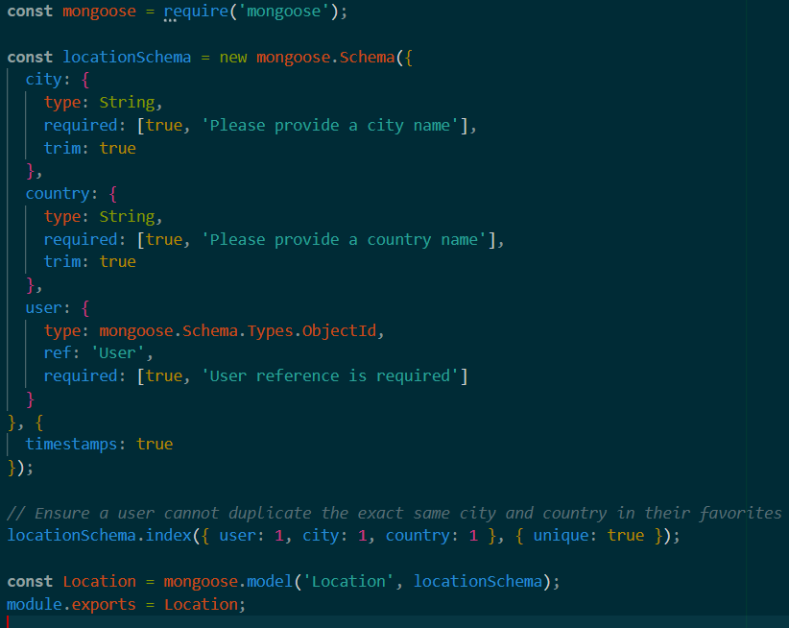
User schema:


Db connection:
This module establishes a connection between the application and MongoDB using Mongoose. It ensures that the backend communicates with the database before processing any client requests.

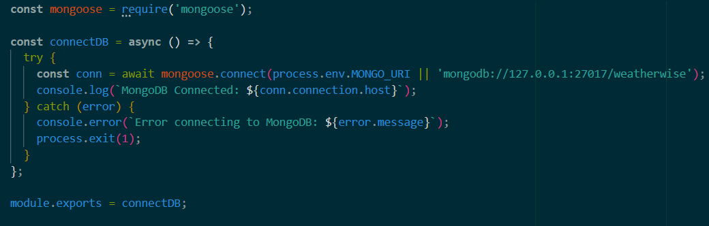

Epic 5: Project Executions:

The AI weatherwise backend can be executed locally using Node.js. Before running the application, ensure that MongoDB is running and the required environment variables are configured correctly. The backend exposes REST APIs that can be tested using Postman or Thunder Client.

Running the Backend Server

Install all required dependencies:
npm install
Start the development server:
npm start
After successful execution, the server connects to MongoDB and starts listening for incoming API requests.

API testing:
Register API:
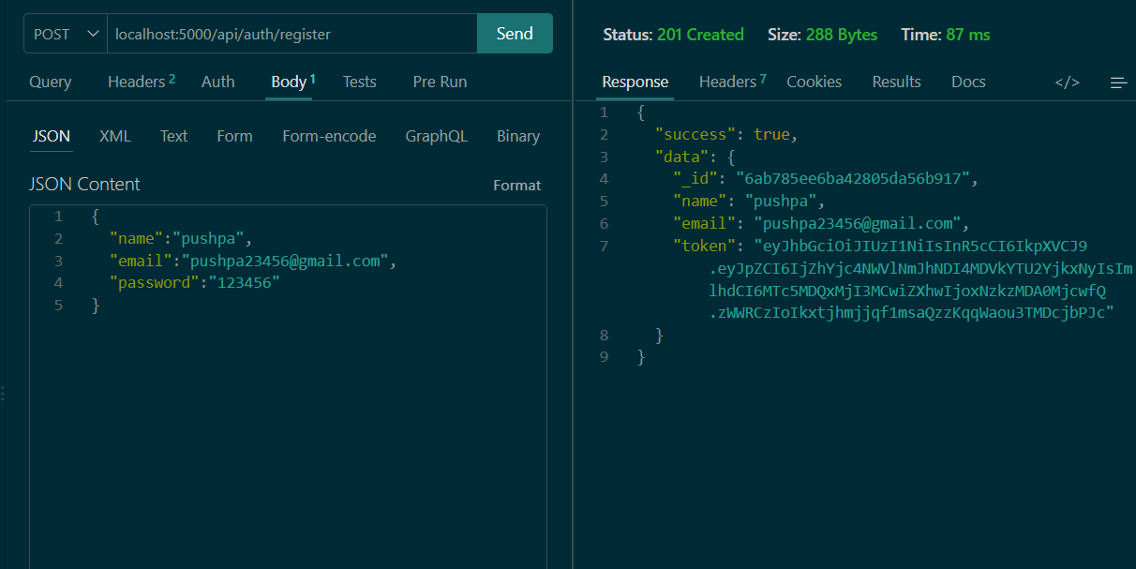
Login API:
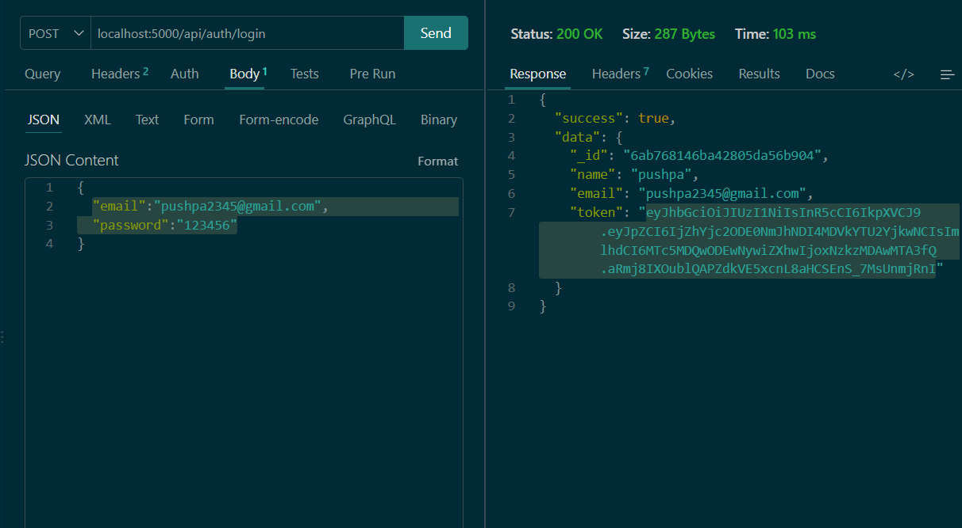
Weather API:
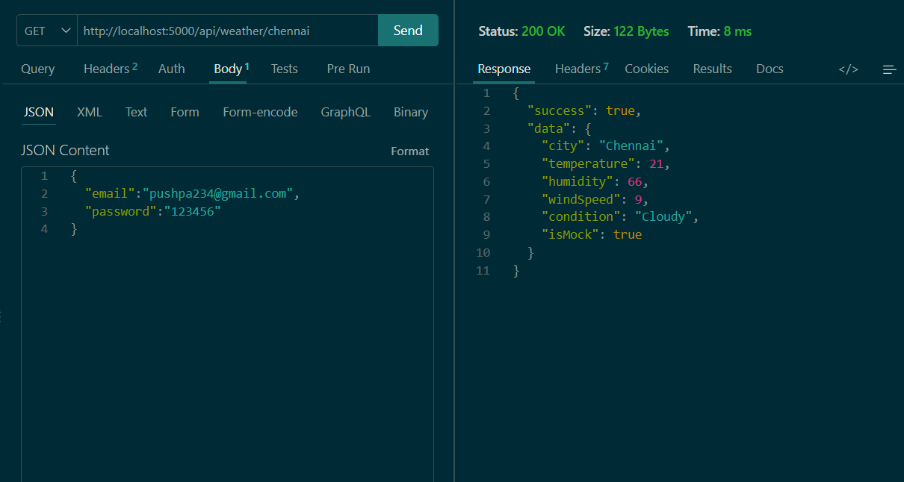
Recommendation API:


